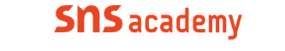

An international CBSE Fingerprint School
Coimbatore

Annual Plan

Chapter No | Topics | Month
6 | Getting started with python | June
7,8 | Python Fundamentals,  Data Handling | July
8,9 | Data Handling,  Flow of control | August
9,10 | Flow of control,  String Manipulation | September
11 | List Manipulation | October
12 | Tuples | November
13 | Dictionaries | December
13,16 | Dictionaries,  Online Access and Computer Security | January
16 | Online Access and Computer Security | February
 | Revision | March

